Genome Wide Association Study of Flowering Time at 10 Degrees Celsius of Arabidopsis thaliana
Research Goal
The goal of this study is to identify the genetic variation that is associated with the quickest flowering time. We do this to identify the variant of Arabidopsis thaliana that results the quickest maturity so we can harvest them faster and bred them to select for the fastest maturating inbred lines. This project is feasible due to the large amount of genomic and associated phenotypic data of Arabidopsis thaliana that is needed for a GWAS to be successful. I hypothesize that we will identify high association with flowering time with gene positions in chromosome 3 based on the figures from the associated journal article.
Methods
From the associated journal article, we downloaded the data and used R to compile the information and conduct our analysis. The genotype data was formatted to allow for the columns to reflect the samples in the phenotype rows. We removed samples (rows) from the phenotype data that are not also samples from the genotype data. We did the same for samples in the genotype data that is not apart of the phenotype data. We now compiled samples that have phenotype and genotype data, which we then remove from both the genotype and phenotype, samples with NA or NULL values, leaving us with complete synonymous data. After which we convert each row into binary, 1 for one of the variants, and -1 for the other which is then used in the package “rrBLUP” GWAS() function.
Results
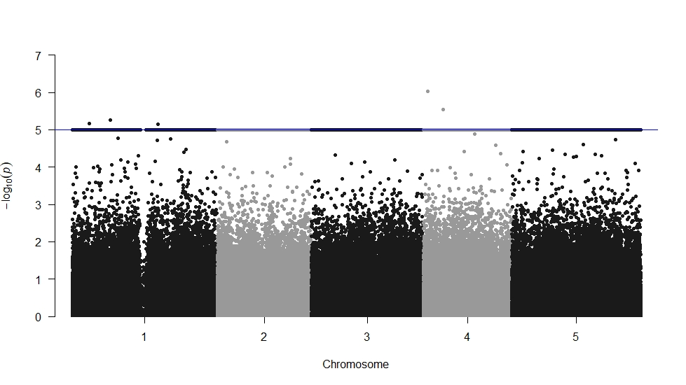
Figure 1: Manhattan plot for the flowering time at 10 degrees Celsius of the Arabidopsis thaliana phenotype for genes in the 5 chromosomes samples.
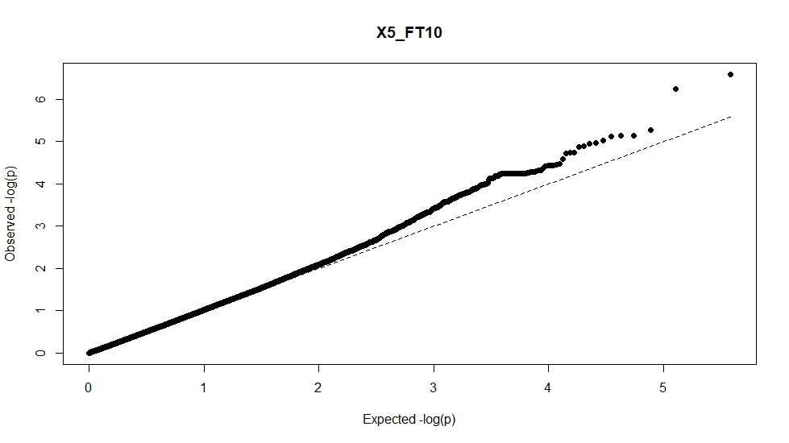
Figure 2: The QQ plot of the GWAS of the phenotype of Flowering time at 10 degrees Celsius and the genotypes sampled for Arabidopsis thaliana.
Supplementary code is attached.
From this analysis, we can see association between phenotype data and genotype data. From the Manhattan plot, we see that the significant regions (above the line) in Figure 1 are mostly found in Chromosome 1, 2 and 4. Looking at the Gene Model data these chromosomes have protein encoding regions that could explain the associative phenotype. Those few regions in the genome that have a high P value on the Manhattan plot could be the cause for the phenotype differences observed in the data. These regions and the genes within them can be used as a starting point for future studies on Arabidopsis thaliana and flowering time. The QQ Plot shows the distribution of our p values compared to the null hypothesis of random association (Figure 2). Random association would be the dotted line representing the null hypothesis. Our observed p value line does curve upwards slightly at the high expected values; however, it may not be enough for this result to be significant. Due to the low number of positions related to the phenotype and the low deviation in the QQ plot in Figure 2, we could conclude that the genotypes observed do not have an association to the phenotype, unless future studies look at the few genotypes that are significant to definitively confirm association. Also, we hypothesized that we would see a similar high association in chromosome 3 based on the study the data was taken from. We did not see this in our study, as such our hypothesis was incorrect.

Method Comparison
I chose to use a GWAS as it made the most sense with the input genotype data being a matrix of samples. I tried to use a linear regression to find an association however, I found it difficult to find statistical power with this type of data. The issue with the GWAS is that it required me to convert the A, T, C and G’s from each sample into 1 and -1, which took many hours which could have been avoided through a linear regression. I learned to process data much in advance and if possible, parallelize these types of analyses.

